Fourteenth USA/Europe Data Exchange Meeting

UK Met. Office Telecommunications Status Report

Prepared By:

David Tinkler
Network Manager Tel: +44 (0)1344 856053
Room R302B Fax: +44(0)1344-856099
Met Office (UK), e-mail: dave.tinkler@metoffice.com
London Road, Bracknell,
Berkshire, RG12 2SZ.

1. Communication Links
Figure 1 UK Met Office Telecommunication links

Figure 1 shows some of the UK Met. Office (UKMO) telecommunications links. The message switches TROPICS and NETTLE send and receive data over the links while the routers UKMO1 and UKMO6 provide the connections to the circuits or managed network services.
The Regional Meteorological Data Communications Network (RMDCN) is a managed IP network service provided by Equant for the WMO National Meteorological Services (NMSs) in WMO region VI. RMDCN also supports X25 encapsulated in IP.
UKMO is making increased use of Frame Relay connections and has links to both British Telecom (Link to Australian BoM) and Worldcom (Link to NESDIS and CMC) Frame Relay services.

The following sections contain more detailed information on some of the links.

1.1 Links to NOAA
There are two links to NOAA, a Frame Relay link to NOAA-NESDIS and a 64KBits/sec leased line to the NOAA Office of Systems Operations (OSO).

1.2.1 Links to NOAA-OSO
The link to NOAA-OSO is a 64Kbits/Sec leased line. There are two separate X25 data streams described in Table 1. The X25 data is encapsulated into IP and sent over the leased line using a router. The link utilisation is shown in Appendix A.

Speed Bits/sec | Protocol | NOAA-OSO System | UKMO | Data
64 K | X25 | NOAA-OSO Telecommunications Gateway | TROPICS | GTS
4.8K | X25 | NOAA-OSO Telecommunications Gateway | TROPICS | T4 Fax Products
Table 1 Details of the links between UKMO and NOAA-OSO

1.2.2 Links to NOAA-NESDIS
The Frame Relay link to NOAA-NESDIS is currently being used for the transfers of satellite sounding data. Details on the link is shown in Table 2, the utilisation is shown in Appendix A and the estimated daily volumes of data is shown in Table 5.

Speed Kbits/sec | Protocol | NOAA-NESDIS System | UKMO | Data
256 Access/ 64 CIR from NESDIS | FTP | CEMSCS | NETLINK | Satellite Sounding data and products, see Table 4
128 Access/ 16 CIR to NESDIS | FTP | CEMSCS | NETLINK | ERS-2 Data
Table 2 Details of the links between UKMO and NOAA-NESDIS

The utilisation graph in Appendix A shows that the majority of the file transfers over the link take place at the access speed of the circuit rather than the Committed Information Rate (CIR).
A link upgrade at the NESDIS end to 512KBits/Sec Access speed and 128KBits/Sec CIR was ordered from Worldcom, the provider in November 2000. At the present time (27/4/2001) they have still not successfully implemented this upgrade.

1.2 Links to ECMWF
The 2MBits/Sec link to ECMWF is used to transmit files of data between UKMO and ECMWF using TCP/IP protocols. This data includes GTS Data, numerical modelling products and satellite data. UKMO users can also submit jobs to run on the ECMWF Cray and access data on ECMWF computer systems using their MARS and METVIEW software.

1.3 Links to RMDCN
The link from UKMO to the RMDCN network has an access speed of 384Kbits/Sec. Permanent Virtual Circuits (PVCs) are established across RMDCN to other National Meteorological Services (NMSs) in WMO region VI. The details of some of these are shown below:

1.3.1 Links to Meteo-France
A PVC with a speed of 128Kbits/Sec out (UKMO to Meteo-France) and 64Kbits/Sec in (Meteo-France to UKMO) has been established.
The link is used for:
- Exchange of GTS and Radar data.
- Sending GOES and GMS satellite data to Lannion. This data is then sent from Lannion to METEOSAT for rebroadcast.
- Transmission of satellite sounding data such as the SSM/I and ATOVS data is sent to Meteo-France using this link.
The intention is to upgrade this link to 128Kbits/Sec from Toulouse to Bracknell and 256Kbits/Sec Bracknell to Toulouse so that the increased satellite imagery received from Melbourne can be sent to Lannion to be inserted in the METEOSAT broadcast.

1.3.2 Links to DWD
A PVC with a speed of 48Kbits/Sec in both directions has been established between the UKMO and DWD. The FTP problem reported at the last meeting has been fixed and GTS data between UKMO and DWD is now using FTP .

1.3.3 Other RMDCN Links
The UKMO has the following PVCs through RMDCN to other NMSs

National Meteorological Service | Protocol | PVC Speed Kbits/Sec | Status
Ireland (Dublin) | FTP | 32 Both ways | Operational
Netherlands (De Bilt) | TCP Sockets | 24 Both ways | Operational
Norway (Oslo) | TCP Sockets | 16 Both ways | Operational
Denmark | TCP Sockets | 16 Both ways | Operational
Italy (Rome) | FTP | 16 Both ways | Operational
Belgium (Brussels) | FTP | 16 Both ways | Operational
Portugal | X25 Over IP | 16 Both ways | Operational
Spain | X25 Over IP | 32 Both ways | Under test
Iceland (Reykjavik) | X25 Over IP | 16 Both ways | Operational
Moscow | FTP | ? | Planned
Table 3 Details of RMDCN Links to other NMSs in WMO Region VI

1.4 Other International Links
In an effort to gain routine, reliable access to global imagery from geostationary satellites, the Met. Office has implemented links as described briefly below. The approach has generally sought to identify mutual benefit from the exchange of satellite data and, hence, sharing of the costs involved.

1.4.1 Australian Met. Service
A Frame Relay link has been established between the UK Met. Office and the Australian Bureau of Meteorology (BoM) in Melbourne. The access speed is 128Kbits/Sec at each end and the CIR is 16Kbits/Sec in both directions. The link is being used for the exchange of data in WMO bulletin format using TCP sockets with TROPICS, files of satellite imagery (METEOSAT from UK and GMS from Australia) and ATOVS level 1c data with NETLINK.
In order to receive more satellite imagery from Melbourne it is planned to increase the CIR of this link to 64KBits/Sec Melbourne to Bracknell and 32Kbits/Sec Bracknell to Melbourne.

1.4.2 Canadian Met. Service
A 32 Kbits/Sec Frame Relay link has been established between the UK Met. Office and the Canadian Met. Service (CMC) in Dorval. It is being used for the exchange of data in WMO bulletin format with TROPICS and files of satellite data (METEOSAT from UK and GOES from Canada) with NETLINK.

2. Met. Office Communication Computer Systems
There are two computer systems at the Met. Office that are used to send data to customers. The TROPICS message switch handles all communications involving X25 protocols and WMO messages, it also has the ability to send WMO messages using FTP or TCP/IP sockets. The NETLINK system has the ability to send files using FTP.
In general TROPICS is used for the transfer of low volume data, typically from 100 Bytes to 50 Kbytes, where high speed data switching is important. NETLINK is used for the distribution of higher volume data at slower data switching speeds.

2.1 NETLINK
The NETLINK computer system is responsible for the operational transfer of files of data between computers on the Met. Office Central Data Network (CDN) and computers on external networks. It consists of two identical Compaq Alpha Computers running OpenVMS, the main system is called NETTLE and its backup is called TEAZLE.
The NETTLE system is a Compaq Alpha 1200/533 with 256 Mbytes of memory running OpenVMS V7.2 operating system. Currently the system is switching 10,000 files per day, which is about 6.5 Gbytes of data.

Table 5 shows the data and its associated volumes sent to NETTLE over the Frame Relay link at present.

Requirements Description | Daily Data Volume (MBytes)
ATOVS Level 1B data | 283.1
SSM/I Brightness temperatures | 231.0
Level 1B TOVS Data | 219.3
Ice/snow gridded field derived from SSM/I data | 80.0
AVHRR Products on a HIRS Grid, derived as part of the NESDIS ATOVS Processing | 31.0
AVHRR 100km and 50Km SSTs | 7.9
AVHRR Mapped Global Area Composites | 6.3
GOES cloud-tracked VIS/IR/WV Winds | 2.6
Ozone Retrieved profiles and/or total column from SBUV on NOAA | 1.1
Total from NESDIS to UKMO | 862.3
Table 4 Data Volumes from NESDIS to UKMO
Description | Daily Data Volume (Mbytes)
ERS-2 data | 9
Total from UKMO to NESDIS | 9
Table 5 Data Volumes from UKMO to NESDIS

Table 6 shows the anticipated increase in data volumes over the next few years based on the data in the present European requirements list and the expected increase in link capacity required to be able to accommodate that data. Over the past year the data volume on the link has increased from 650MBytes to 862 MBytes without an increase in link speed. No problems with the timing of received data have been reported. However, the present link runs at the frame relay access speed but this speed could drop to the committed information rate (CIR) if the suppliers network becomes congested. It is proposed that the link is operated at a CIR similar to the average daily data rate with an access speed four times that value. As long at the network continues to operate at the access peed there should be sufficient bandwidth and if the network becomes congested and the data rate drops we can pay to increase the CIR (up to 80% of the access speed). With present predicted data volumes this means we would increase the link speed mid 2002 to accommodate the expected future data increases.

Date | Data Volume (Mbytes) | Average Link Speed (Kbits/Sec) | Link CIR (Kbits/Sec) | Link Access Speed (Kbits/Sec) | Additional Data Requirement
01/07/2000 | 650.0 | 60.2 | 64 | 256
01/10/2000 | 862.3 | 79.8 | 64 | 256 | NOAA-L
01/01/2001 | 862.3 | 79.8 | 64 | 256
01/04/2001 | 862.3 | 79.8 | 64 | 256
01/07/2001 | 1073.3 | 99.4 | 128 | 512 | Quickscatt, NOAA-L AVHRR & NCEP Sea Ice
01/10/2001 | 1073.3 | 99.4 | 128 | 512
01/01/2002 | 1473.3 | 136.4 | 128 | 512 | SSM/IS, AIRS and AMSU on AQUA
01/04/2002 | 1473.3 | 136.4 | 128 | 512
01/07/2002 | 1473.3 | 136.4 | 256 | 1024
01/10/2002 | 1883.3 | 174.4 | 256 | 1024 | SEAWINDS on ADEOS & WINDSAT
01/10/2003 | 1883.3 | 174.4 | 256 | 1024
Table 6 Future Data Volumes on the NESDIS Frame Relay Link.

2.2 TROPICS
The TROPICS system at Bracknell is a multi-computer Tandem K2000 Himalaya system; one computer system called TROPICS(A) is used to meet our national and international message switching needs. As such it supports some communications links ranging from low speed asynchronous connections to 64KBits/s synchronous lines although increasing the connections are made through routers and data sent out via the Ethernet LAN interfaces.
The main messages are transferred using FTP, TCP sockets and X25 but there is also support for messaging via telex, ISO TP4 (over LAN) and X.400.

The TROPICS(A) message switch is an eight processor system with 128MBytes of memory per processor running the non-stop Kernel D45 release of operating system. Currently the system is switching 1.9 million half-messages per day, which is about 3.5 Gbytes. Peak rates are around 45 half-messages per second, which is about 133 Kbytes/sec.

With regard to the "alpha-numeric observational" and GRIB channels between Bracknell and NOAA-OSO the following tables show the change in daily traffic rates since the last meeting: -

Date | Washington to Bracknell |  | Bracknell to Washington
 | Data (Mb) | Msgs | Data (Mb) | Msgs
April 1996 | 9.2 | 14256 | 9.1 | 13651
May 1997 | 9.6 | 15535 | 10.4 | 14662
May 1998 | 13.2 | 16524 | 11.0 | 15884
May 1999 | 17.5 | 18036 | 12.4 | 19199
June 2000 | 21.3 | 22123 | 14.2 | 24359
April 2001 | 32.7 | 23011 | 16.4 | 28925

Table 6 GTS Link Alpha-Numeric Channel

Date | Washington to Bracknell |  | Bracknell to Washington
 | Data (Mb) | Msgs | Data (Mb) | Msgs
April 1996 | 72.8 | 19455 | 75.9 | 23463
May 1997 | 75.6 | 19220 | 77.3 | 23007
May 1998 | 80.1 | 19932 | 66.5 | 16259
May 1999 | 78.7 | 19876 | 68.7 | 16343
June 2000 | 83.1 | 20389 | 75.3 | 17763
April 2001 | 86.1 | 20740 | 86.6 | 20006

Table 7 GTS Link GRIB Channel

Date | Washington to Bracknell |  | Bracknell to Washington
 | Data (Mb) | Msgs | Data (Mb) | Msgs
April 2001 | 5.4 | 59 | 5.4 | 60
Table 7 GTS Link T4 Channel

2.3 FROST

The Met Office is currently undertaking a project (name FROST) to replace the TROPICS message switches. It is expected that they will be replaced with a UNIX based system running packaged message switching software. It is hoped to award a contract for the supply of this new system in May or June 2001, subject to successful contract negotiations and an acceptable final cost. Assuming such a contract is awarded, the new system should be operational in the first quarter of calendar 2002. There should be little if any impact upon existing TROPICS links as all existing protocols and message formats will continue to be supported.
Appendix A Utilisation of UK Met. Office Links to NOAA

A1 Links to NOAA-OSO

A1.1 Utilisation of GTS Link between UKMO and NOAA-OSO

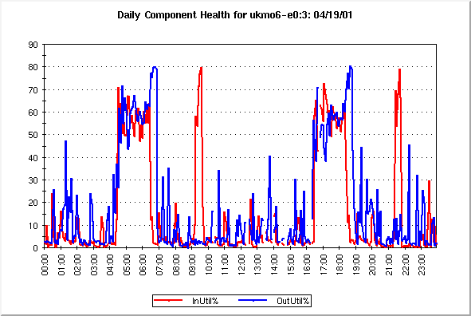

The graph shows the input and output utilisation of the GTS link to NOAA-OSO relative to the bandwidth of 64Kbits/Sec.
A1.2 Utilisation of the T4 Chart Link between UKMO and NOAA-OSO

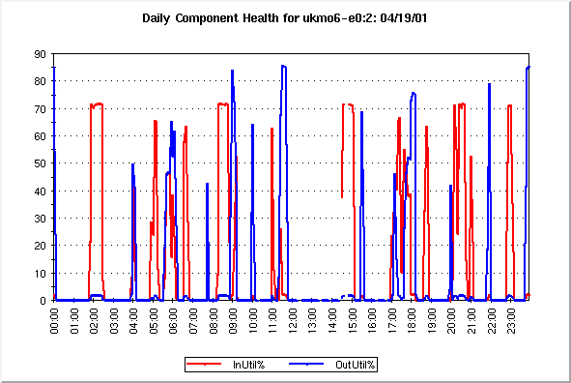

The graph shows input and output utilisation of the T4 link to NOAA-OSO relative to the bandwidth of 4Kbits/Sec

A2 Frame Relay Link to NOAA-NESDIS

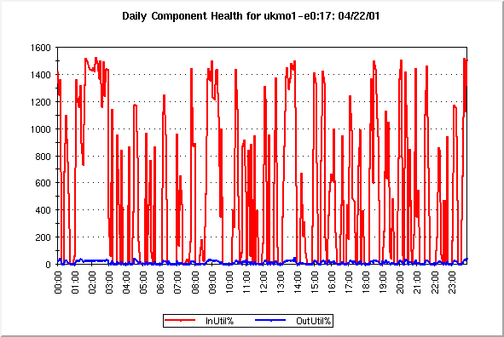

The graph shows the input and output utilisation of the Frame Relay link to NESDIS relative to a bandwidth of 16Kbits/Sec. This makes 1600% equivalent to 256Kbits/Sec.

